ID 2272583

Exam for 35324 - LC Mathematical and Logical Foundations of Computer Science

After inserting your student ID and the module name in the title, header and footer, write your answers between here and the statement of good academic conduct. Your ID and the module name will automatically appear on any subsequent pages.

Q1

(a)

(i)

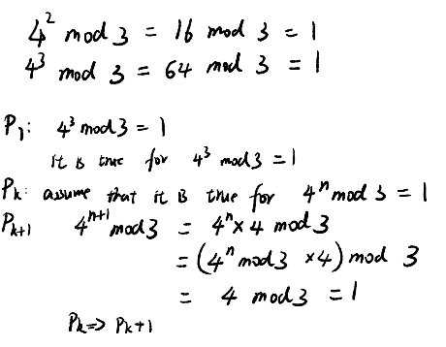



(ii)



(iii)



(b)

(i)

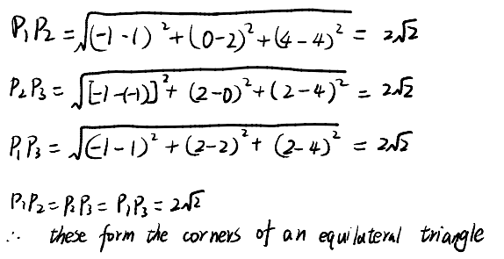

(ii)

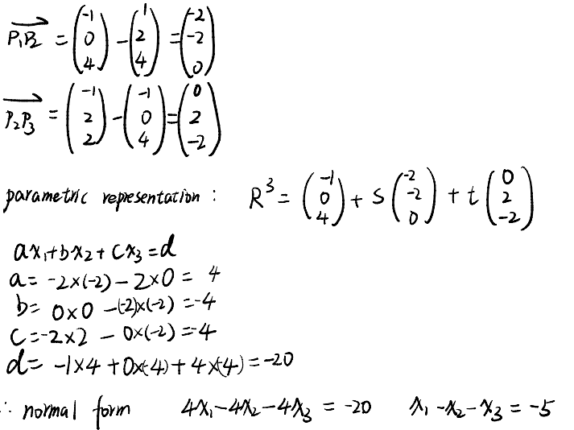

(iii)

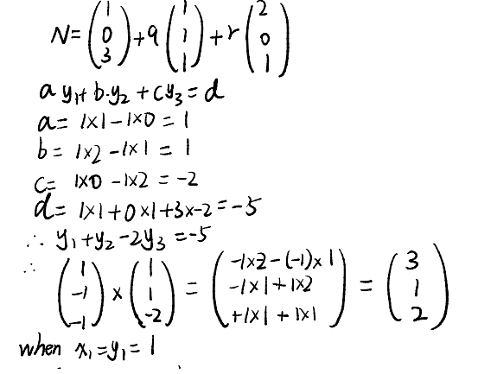

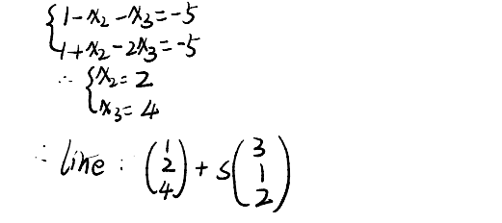

Q2

(a)

(i)

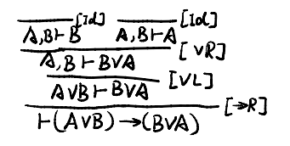

(ii)

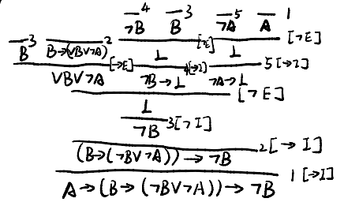

(iii)

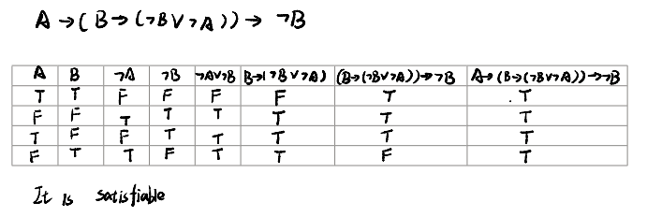

(b)

(i)

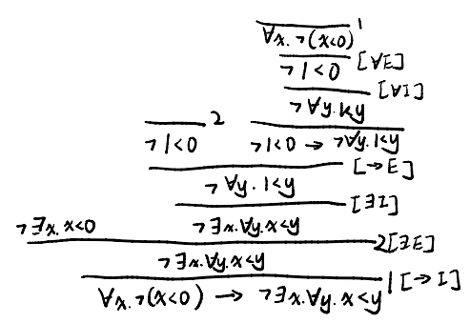

(ii)

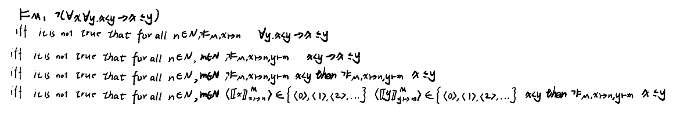

Do not write below this line

Statement of good academic conduct

By submitting this assignment, I understand that I am agreeing to the following statement of good academic conduct:

* I confirm that this assignment is **my own work** and I have not worked with others in preparing this assignment.
* I confirm this assignment was written by me and is in my own words, except for any materials from published or other sources which are clearly indicated and acknowledged as such by appropriate referencing.
* I confirm that this work is not copied from any other person's work (published or unpublished), web site, book or other source, and has not previously been submitted for assessment either at the University of Birmingham or elsewhere.
* I confirm that I have not asked, or paid, others to prepare any part of this work for me.
* I confirm that I have read and understood the University regulations on plagiarism (<https://intranet.birmingham.ac.uk/as/registry/policy/conduct/plagiarism/index.aspx>).